**WEEK 1**

1. Project Board Link:

<https://trello.com/b/WeAGgNnf/capstone-project-job-recommendation-and-resume-customization-system>

1. Project Board Screenshot(s):

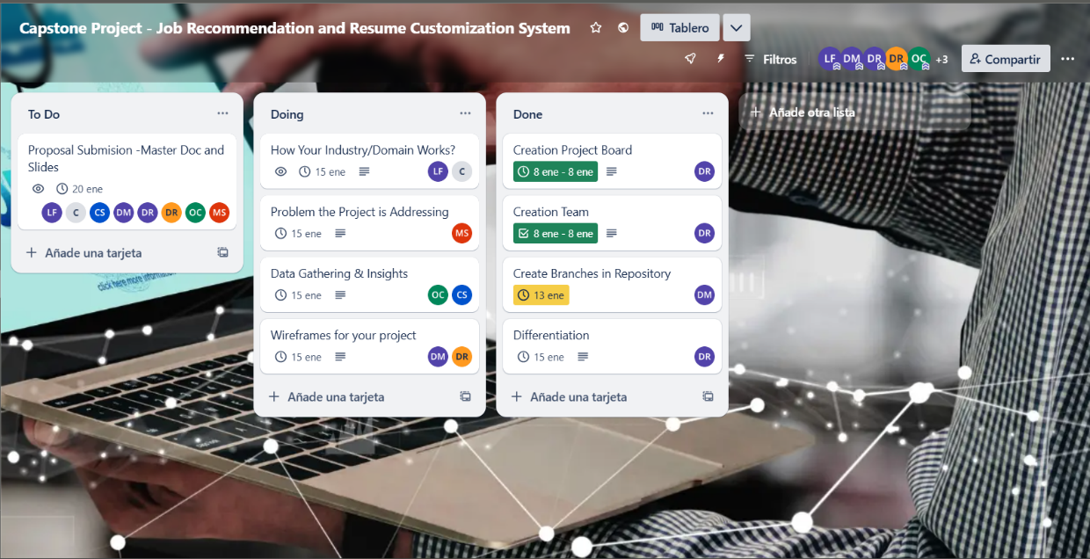

Move to Git Hub

Diagram about the process

Target audience

1. Git Repo Link:

<https://github.com/LCM-W25-3035/AutoApply.git>

1. Git Commits/Merges Screenshot(s) for each Team Member:

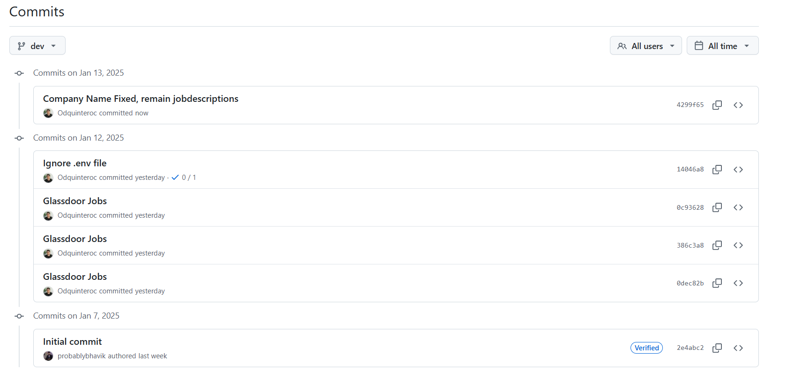

1. Big Data Pipelines built so far:
2. SonarQube Screenshot(s):
3. Test Cases Fixed/Passed since the last Progress Report (List or Screenshot):
4. Test Cases Still Failing (List or Screenshot):
5. New Failing Test Cases Identified since the last Progress Report (List or Screenshot):
6. Current Documentation Coverage (List or Screenshot):

1. Pending Functionalities/Features/Research for Documentation (List or Screenshot):

**Evidence of Glassdoor API answered.**

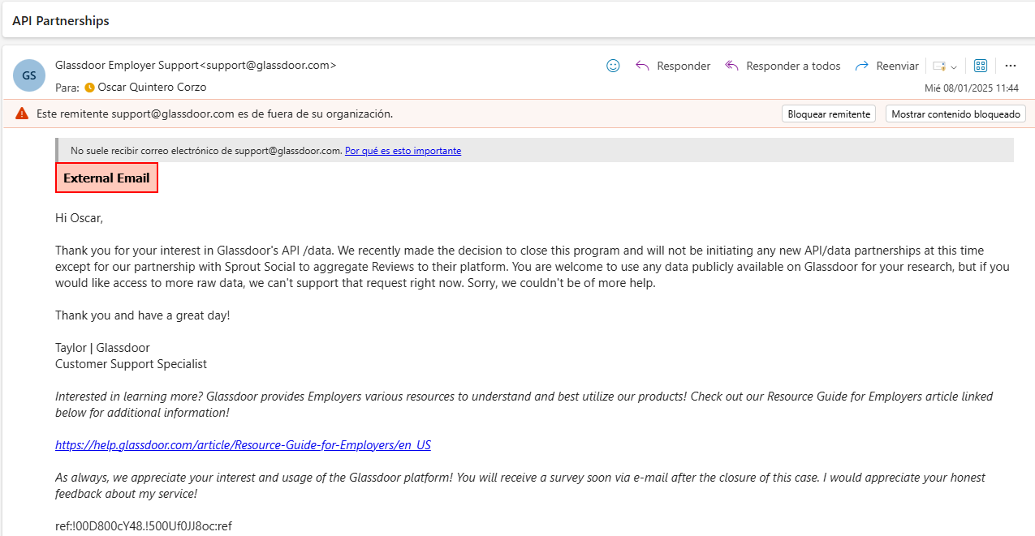

**Evidence of Indeed API answered.**

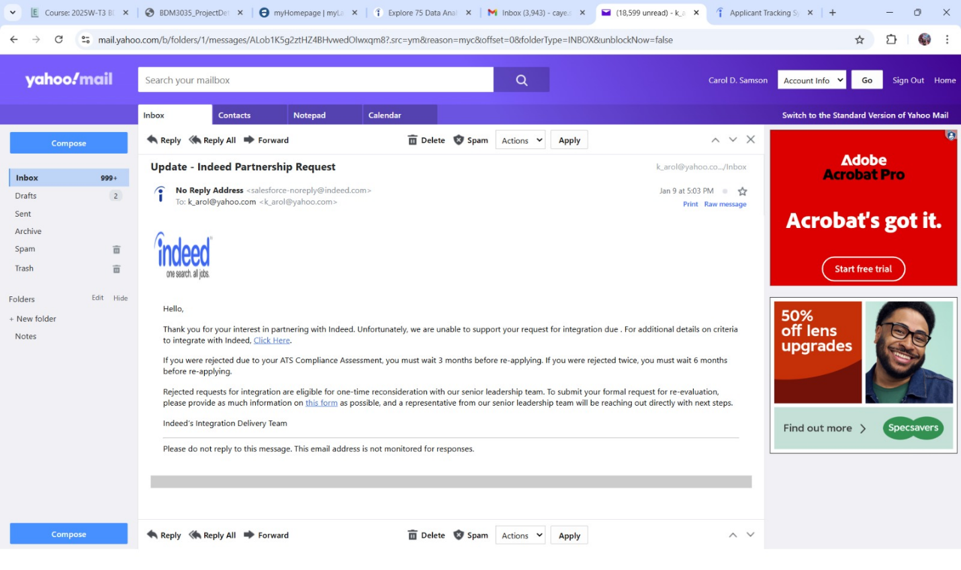

1. Deployment Readiness/Status/Tasks (List or Screenshot):

Weekly Check-In

|  |  |  |  |  |
| --- | --- | --- | --- | --- |
| Member Name | Email | Role | Task Done | Hours Worked |
| Leidy Tatiana Rojas | c0923904@mylambton.ca | Team Leader | 1. Search for statistics related to the job search process  2. Search for information on what ATS are and how they currently work  3. Creation and structuring of Proposal Submission document -  Start of redaction Point 1 - How your industry/domain works? | 1 hour  0.5 hours  2 hours |
| Daniel Andres Gonzalez | c0922914@mylambton.ca | Technical Leader | 1. Ideation and structuring of wireframes, workflows, and pipelines. | 4 hours |
| Carol Samson | c0917154@mylambton.ca | Member group | 1. Set up a new account in Octoparse application to try to scrape data from Indeed and Google using the built in API  2. Created insights from job and resume data provided by professor | 1 hour  2 hours |
| Mya Hnin Si | c0922606@mylambton.ca | Member group | Researched the problems the project is addressing and wrote the report | 4 hours |
| Diana Mayorga | c0926202@mylambton.ca | Member group | 1. 1. Define components and tools to be used   2. Structure the process and connect the components  3. Generate a mockup of the web application | 4 Hours |
| Oscar Quintero | c0922321@mylambton.ca | Member group | 1. Attempt to connect and use the Glassdoor API to collect IT job offers.  2. Explore web scraping techniques with Python to collect job information directly from the Glassdoor website. | 4 hours |
| David Rocha | c0927458@mylambton.ca | Member group | 1. Set up a Trello Kanban board and add project members.  2. Created a shared group in Microsoft Teams for collaboration.  3. Proposed an agenda for progress review meetings.  4. Researched 14 competitor tools to identify market gaps through benchmarking.  5. Developed a differentiated value proposition for the new system. | 0.5 hours  0.5 hours  0.5 hours  1.5 hours  1 hour |
| Mohkampreet Kaur | c0928471@mylambton.ca | Member group | 1.Researched how to analysis the Resume for extracting the structured data.  2. collected the information how job offers helps in identifying skills, Requirements.  3. Researched how to customizes the Resume  Point 1 - How your industry/domain works? | 1 hours  2 hours  1 hours |